

REAL

-

TIME

VIOLENCE ALERT SYSTEM

**Guide : Ms.**

**Jayalekshmi**

**J**

**Co**

**-**

**guide : Ms.**

**Dhanya**

**L K**

**Presented By**

o

**Prathamesh Garade 21510015**

o

**Dhruv Herwade 21510040**

o

**Sanket Gaikwad 21510114**



Problem Statement

⬡

**CCTV Surveillance is used to a greater extent but still it lacks the feature**

**of automatic violence detection**

⬡

**Manual**

**monitoring**

**is not a feasible task and the time taken to respond**

**to the situation is also crucial**

⬡

**A Real**

**-**

**Time violence alert is proposed**



Architecture Diagram

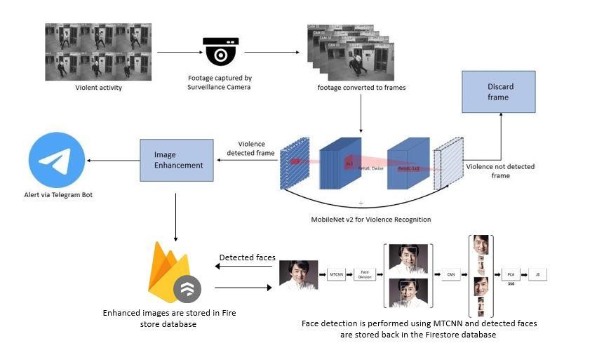

Alert Module

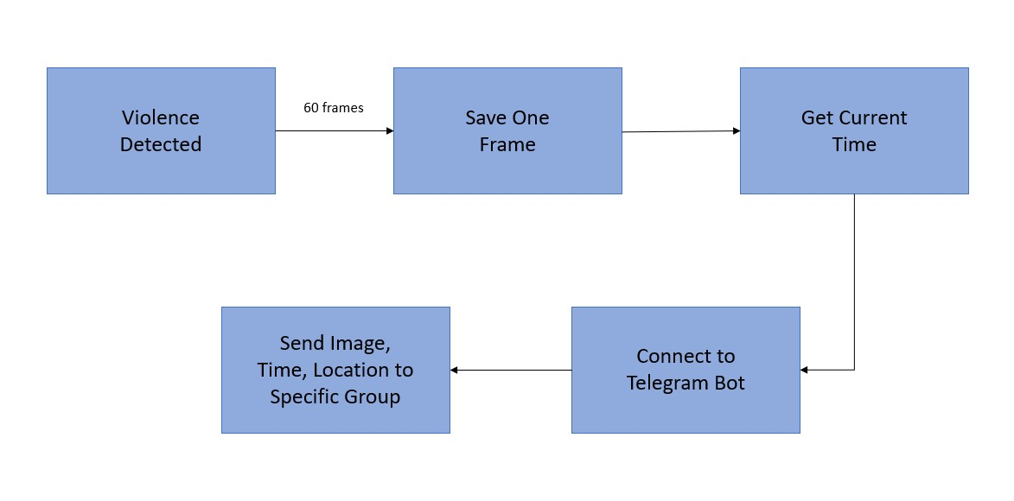

Image Enhancement

⬡

**Sharpness and color of obtained output frames is slightly improved**

⬡

**Uses inbuilt functions**

**–**

**Python PIL Library**

⬡

**Helps authorities in face detection & cross**

**-**

**checking**



Face Detection

⬡

**MTCNN and Pyplot are used**

⬡

**MTCNN consists of 3 stages of CNN for face detection and face alignment**

⬡

**Pyplot is a submodule of the matplot library**



Methodology

o

**A dataset having 1000 videos each of violence category and non**

**-**

**violence category was chosen**

o

**A model was trained using MobileNetV2 using the dataset**

o

**Real**

**-**

**time video footage is given as input**

o

**Output is obtained as image frames**



MobileNet V2

o

**Convolutional neural network that is 53 layers deep**

o

**Provides real**

**-**

**time classification capabilities under computing**

**constraints in devices like smartphones.**

o

**Utilizes an inverted residual structure where the input and output of**

**the residual blocks are thin bottleneck layers.**

o

**Uses lightweight convolutions to filter features in the expansion layer.**



Firebase

o

**Built by Google**

o

**Provides services like Storage,**

**Analysis, Machine Learning etc.**

o

**Firebase storage bucket is used to store the image**

o

**Links are obtained for the images and stored in**

**firestore**

**along with**

**date and time**



Results

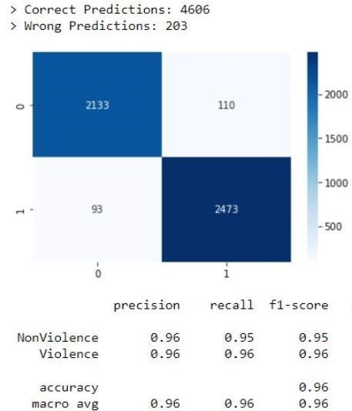

Results



References

* [1] Mi Young Lee, Ijaz Ul Haq, Seungmin Rho, Sung Wook Baik, and Samee Ullah Khan Cover the Violence: A

Novel Deep-Learning-Based Approach Towards Violence-Detection in Movies, MDPI Article Received: 3

October 2019; Accepted: 7 November 2019; Published: 18 November 2019 o [2] M. -S. Kang, R. -H. Park and H. -M. Park, "Efficient Spatio-Temporal Modeling Methods for Real-Time Violence Recognition," in IEEE Access, vol. 9, pp. 76270-76285, 2021, doi: 10.1109/ACCESS.2021.3083273, Date of Publication: 25 May 2021.

* [3] Zhou P, Ding Q, Luo H, Hou X (2018) Violence detection in surveillance video using lowlevel features. PLoS

ONE 13(10): e0203668. https://doi.org/10.1371/journal.pone.0203668, Published: October 3,

2018[4]https://towardsdatascience.com/review-mobilenetv2-light-weight-model-image-classification-

8febb490e61c o [4]https://towardsdatascience.com/review-mobilenetv2-light-weight-model-image-classification8febb490e61c



Thank You

